**VISHWAKARMA INSTITUTE OF TECHNOLOGY**

COMPUTER ENGINEERING

**Name: Srinivas Sanjeevkumar Chenna**

**Division: A**

**Roll Number: 48**

**Subject: Operating System (OS)**

**Assignment 6**

**Write a shell script for**

1. **To convert given binary number into decimal number.**

Code:

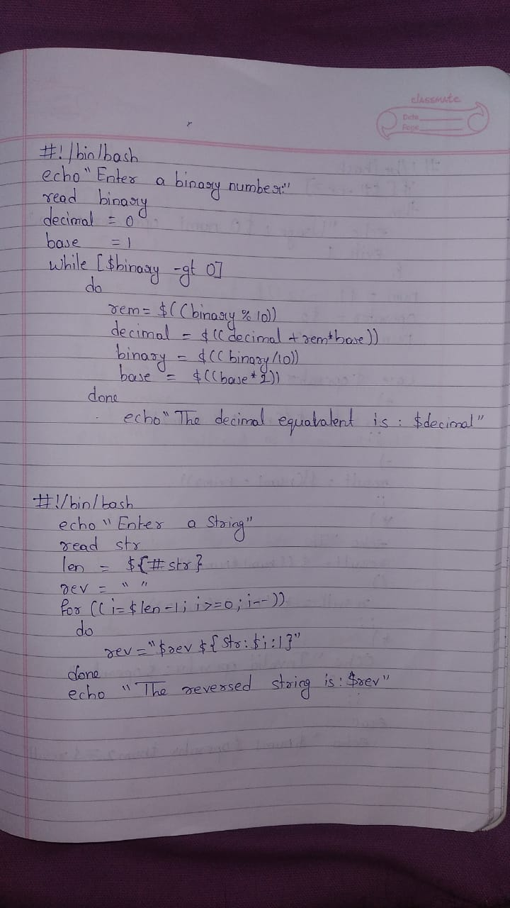

Output:

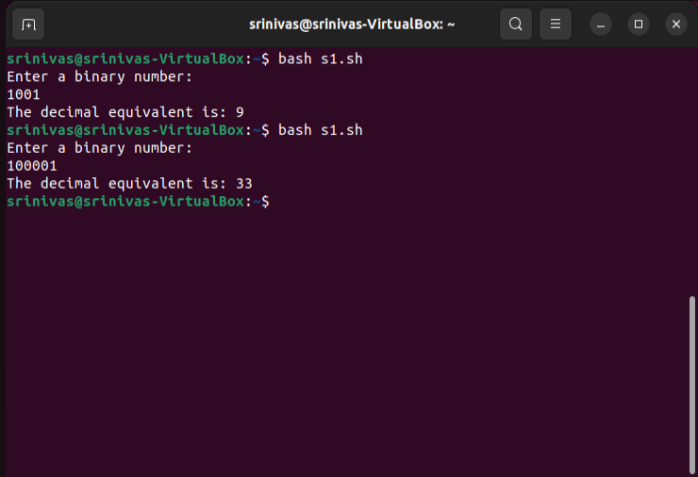

1. **To accept the strings & to reverse the string.**

Output:

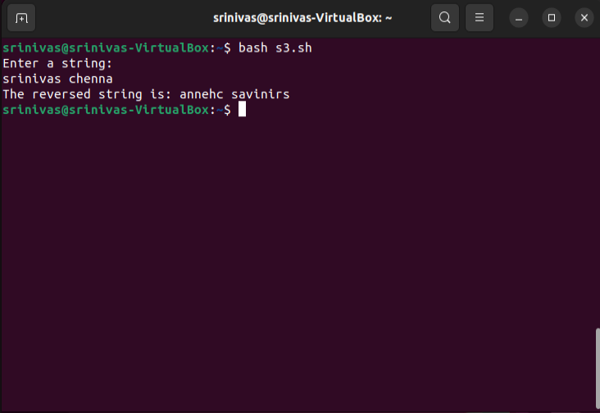

1. **To design a calculator using command line arguments.**

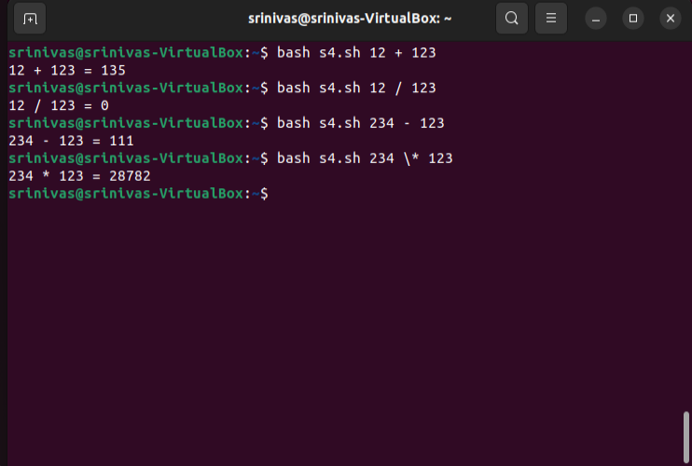

1. **To write a function to calculate the factorial of a number**

Code:

Output:

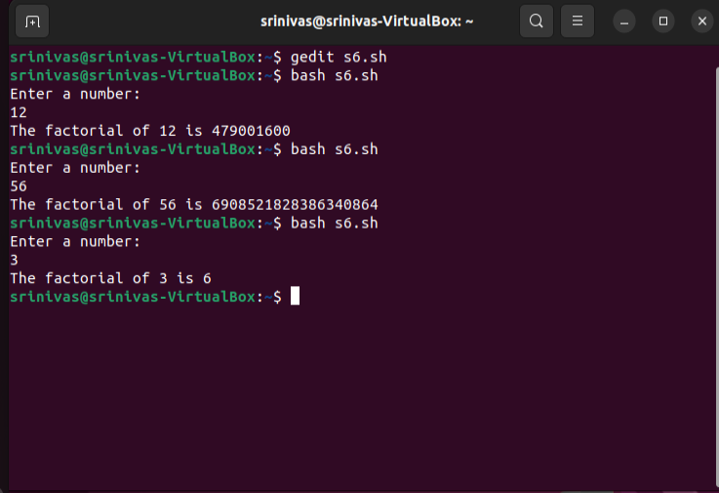

1. **To print the pyramid of *.**

Code:

Output:

